

National Textile University
Department of Computer Science
Subject: Operating System

Submitted to: Sir Nasir

Submitted by: Hadi

Reg. number: 23-NTU-CS-1160
After Mid’s first Homework
Semester:5th

Operating Systems – COC 3071
SE 5th A – Fall 2025
After-mid Homework -1

Part 1: Semaphore theory
- A counting semaphore is initialized to 7. If 10 wait() and 4 signal() operations are performed, find the final value of the semaphore.
Initial value = 7
- 10 wait() → 7 − 10 = −3
- 4 signal() → −3 + 4 = 1
- Semaphore value is 1

- A semaphore starts with value 3. If 5 wait() and 6 signal() operations occur, calculate the resulting semaphore value.

Initial value = 3
- 5 wait() → 3 − 5 = −2
- 6 signal() → −2 + 6 = 4
- Final semaphore value = 4

- A semaphore is initialized to 0. If 8 signal() followed by 3 wait() operations are executed, find the final value.
Initial value = 0
- 8 signal() → 0 + 8 = 8
- 3 wait() → 8 − 3 = 5
- Final semaphore value = 5

- A semaphore is initialized to 2. If 5 wait() operations are executed:
Initial value = 2
- 5 wait() operations

- How many processes enter the critical section?
- Only 2 processes can enter (value becomes 0)

- How many processes are blocked?
Remaining waits = 5 − 2 = 3 blocked
Answer:
- Enter CS = 2
- Blocked = 3
5. A semaphore starts at 1. If 3 wait() and 1 signal() operations are performed:
Initial value = 1
- 3 wait() → 1 − 3 = −2
- 1 signal() → −2 + 1 = −1

a) Processes blocked
- Semaphore −1 → 1 process blocked

b) Final value
- Final semaphore value = −1

6.
semaphore S = 3;
wait(S) =2 wait(S)=1
signal(S)=2 wait(S)=1
wait(S)=0

- How many processes enter the critical section?
- Semaphore never goes negative → 5 processes enter

- What is the final value of S?

- S=0

7.
semaphore S = 1;
S = 1
wait(S) → 0
wait(S) → -1 (blocked)
signal(S) → 0 (one wakes)
signal(S) → 1

- How many processes are blocked?
Only one
- What is the final value of S?
One (s=1)

8.
A binary semaphore is initialized to 1. Five wait() operations are executed without any signal(). How many processes enter the critical section and how many are blocked?
Binary semaphore = 1
- 5 wait() without signal
- 1 process enters CS
- Remaining 4 are blocked
Answer:
- Enter CS = 1
- Blocked = 4

9.A counting semaphore is initialized to 4. If 6 processes execute wait() simultaneously, how many proceed and how many are blocked?
Initial value = 4
- 6 wait() simultaneously
- 4 proceed
- 6 − 4 = 2 blocked
Answer:
- Proceed = 4
- Blocked = 2

10.A semaphore S is initialized to 2.

- Track the semaphore value after each operation.
- wait(S)=1
- wait(S)=0
- wait(S)=-1 (blocked)
- signal(S)=0
- signal(S)=1
- wait(S)=0

- How many processes were blocked at any time?
- One process was blocked

11. A semaphore is initialized to 0. Three processes execute wait() before any signal(). Later, 5 signal() operations are executed.
Initial value = 0
- 3 processes wait() → 3 blocked
- 5 signal() operations

- How many processes wake up?
3 processes wake up
- What is the final semaphore value?
Semaphore value=2

Part 2: Semaphore Coding
Consider the Producer–Consumer problem using semaphores as implemented in Lab-10 (Lab-plan attached). Rewrite the program in your own coding style, compile and execute it successfully, and explain the working of the code in your own words.
Submission Requirements:
- Your rewritten source code
- A brief description of how the code works
- Screenshots of the program output showing successful execution

Code:
#include <stdio.h>
#include <pthread.h>
#include <semaphore.h>
#include <unistd.h>

#define BUF_SIZE 5
#define PRODUCE_COUNT 3
#define THREADS 2

// Shared buffer and indices
int sharedBuffer[BUF_SIZE];
int writeIndex = 0;
int readIndex = 0;

// Synchronization primitives
sem_t semEmptySlots;
sem_t semFilledSlots;
pthread_mutex_t bufferLock;

// Producer thread function
void* producerTask(void* arg) {
int producerId = *(int*)arg;

for (int i = 0; i < PRODUCE_COUNT; i++) {
int data = producerId * 100 + i;

// Wait until an empty slot is available
sem_wait(&semEmptySlots);

// Lock buffer before accessing it
pthread_mutex_lock(&bufferLock);

sharedBuffer[writeIndex] = data;
printf("Producer %d produced %d at index %d\n",
producerId, data, writeIndex);

writeIndex = (writeIndex + 1) % BUF_SIZE;

// Unlock buffer
pthread_mutex_unlock(&bufferLock);

// Signal that a new item is available
sem_post(&semFilledSlots);

sleep(1);
}
return NULL;
}

// Consumer thread function
void* consumerTask(void* arg) {
int consumerId = *(int*)arg;

for (int i = 0; i < PRODUCE_COUNT; i++) {

// Wait until a filled slot is available
sem_wait(&semFilledSlots);

// Lock buffer before accessing it
pthread_mutex_lock(&bufferLock);

int data = sharedBuffer[readIndex];
printf("Consumer %d consumed %d from index %d\n",
consumerId, data, readIndex);

readIndex = (readIndex + 1) % BUF_SIZE;

// Unlock buffer
pthread_mutex_unlock(&bufferLock);

// Signal that a slot is now empty
sem_post(&semEmptySlots);

sleep(2); // Consumer is slower
}
return NULL;
}

int main() {
pthread_t producers[THREADS], consumers[THREADS];
int threadIds[THREADS] = {1, 2};

// Initialize semaphores and mutex
sem_init(&semEmptySlots, 0, BUF_SIZE);
sem_init(&semFilledSlots, 0, 0);
pthread_mutex_init(&bufferLock, NULL);

// Create producer and consumer threads
for (int i = 0; i < THREADS; i++) {
pthread_create(&producers[i], NULL, producerTask, &threadIds[i]);
pthread_create(&consumers[i], NULL, consumerTask, &threadIds[i]);
}

// Wait for threads to finish
for (int i = 0; i < THREADS; i++) {
pthread_join(producers[i], NULL);
pthread_join(consumers[i], NULL);
}

// Cleanup resources
sem_destroy(&semEmptySlots);
sem_destroy(&semFilledSlots);
pthread_mutex_destroy(&bufferLock);

return 0;
}

Terminal:

Part 3: RAG (Recourse Allocation Graph)
- Convert the following graph into matrix table ,

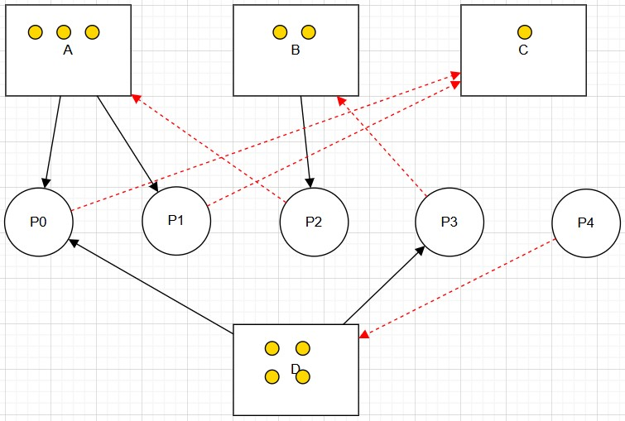

- Allocation matrix
Process | A | B | C | D
P0 | 1 | 0 | 0 | 1
P1 | 1 | 0 | 0 | 0
P2 | 0 | 1 | 0 | 0
P3 | 0 | 0 | 1 | 1
P4 | 0 | 0 | 0 | 0

- Request matrix
Process | A | B | C | D
P0 | 0 | 0 | 0 | 0
P1 | 1 | 0 | 1 | 0
P2 | 1 | 0 | 1 | 0
P3 | 0 | 1 | 0 | 0
P4 | 0 | 0 | 0 | 1

Part 4: Banker's Algorithm
System Description:
- The system comprises five processes (P0–P3) and four resources (A,B,C,D).
- Total Existing Resources:

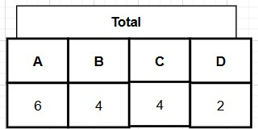

- Snapshot at the initial time stage:
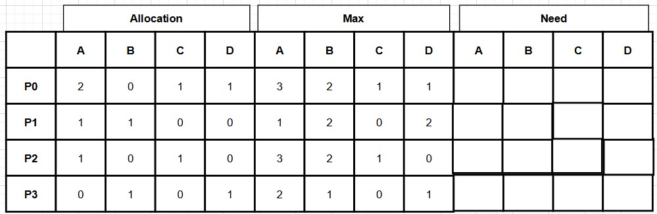
•
Questions:
- Compute the Available Vector:

• Calculate the available resources for each type of resource.
Total resources:
A=0,B=4,C=4,D=2
- Available matrix
Total allocated:
    - A: 2 + 1 + 1 + 0 = 4
    - B: 0 + 1 + 0 + 1 = 2
    - C: 1 + 0 + 1 + 0 = 2
    - D: 1 + 0 + 0 + 1 = 2
Total - total allocated
    - A: 6 - 4 = 2
    - B: 4 - 2 = 2
    - C: 4 - 2 = 2
    - D: 2 - 2 = 0
Available Vector: [2,2,2,0]

- Compute the Need Matrix:
• Determine the need matrix by subtracting the allocation matrix from the maximum matrix.
The Need Matrix is calculated using the formula: Need = Max - Allocation.

Process | Max (A B C D) | Allocation (A B C D) | Need (A B C D)
P0 | 3 2 1 1 | 2 0 1 1 | 1 2 0 0
P1 | 1 2 0 2 | 1 1 0 0 | 0 1 0 2
P2 | 3 2 1 0 | 1 0 1 0 | 2 2 0 0
P3 | 2 1 0 1 | 0 1 0 1 | 2 0 0 0

- Safety Check:
  - Determine if the current allocation state is safe. If so, provide a safe sequence of the processes.
  - Show how the Available (working array) changes as each process terminates.

To determine if the state is safe, we find a sequence where each process's Need <= Available. Once a process finishes, it releases its Allocation back to the Available pool.

Step | Process | Need | Available (Work) | Can it run? | New Available (Work + Allocation)
1 | P0 | [1, 2, 0, 0] | [2, 2, 2, 0] | Yes | [2,2,2,0] + [2,0,1,1]={[4, 2, 3, 1]}
2 | P2 | [2, 2, 0, 0] | [4, 2, 3, 1] | Yes | [4,2,3,1] + [1,0,1,0]={[5, 2, 4, 1]}
3 | P3 | [2, 0, 0, 0] | [5, 2, 4, 1] | Yes | [5,2,4,1] + [0,1,0,1]={[5, 3, 4, 2]}
4 | P1 | [0, 1, 0, 2] | [5, 3, 4, 2] | Yes | [5,3,4,2] + [1,1,0,0] ={[6, 4, 4, 2]}

Yes. Safe Sequence: {P0, P2, P3, P1}

